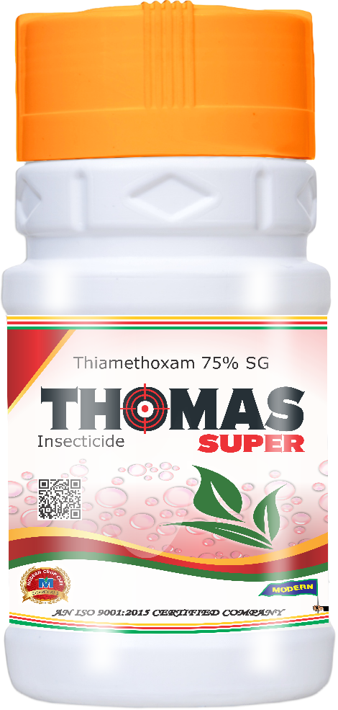
Product Name :- THOMAS SUPER
Technical Name :- Thiamethoxam 75% SG
Description :- Thomas Super insecticide is a broad-spectrum systemic action insecticide that belongs to the neonicotinoid group. Thiamethoxam molecule in Thomas Super insecticide acts as systemic action and inhibits a specific protein in the brain (nicotinic Acetylcholine receptor), which disrupts the reflex actions in pests.
Packing :- 125gm, 250gm, 500gm
Crops :- Cotton, Paddy, Groundnut, Sugarcane.

Disease/Pests :- Jassids, Thrips, GLH & BPH, Termites, Early Shoot Borer.

